“Why a Jewish state is a bad idea”.
Thursday 21 September, 7.00 for 7.30pm at Sarum College.

Ofra Yeshua Lyth, Israeli journalist and columnist will make the case for one secular and democratic state in Israel/Palestine. Raised as a Zionist and having served in the Israeli army, she worked as foreign correspondent for the second largest Israeli newspaper Maariv in Germany and the United States.

Her latest book, “Politically Incorrect: why a Jewish state is a bad idea”, shows how the religious foundations of the Israeli-Zionist politics are determining not only matters of death, marriage and divorce under the strict jurisdiction of the country’s rabbis but how they also affect the way the non-Jewish natives of the land are being treated on a daily basis. The book, which will be on sale, is full of wry humour as well as deeply serious insights. This event is being organised by Sarum Concern for Israel/Palestine (SCIP).

An Autumn Study Course on “JESUS THE JEW”
What he could and couldn’t do; What he did and didn’t do.

This historical study of Jesus in his context relates to his teaching; his paradoxical works; the company he kept; his symbolic actions; and the titles by which he was known. We shall aim to understand the significance of his choices amid the options.

Six Evening Sessions: 7.30 to 9.00 pm
Mondays, October 2, 9, 16 (not 23), 30, November 6 & 13
Meeting at St Thomas’s Church Rooms
Registration: to ensure provision of materials, preferably by e-mail to plucas@mybroadbandmail.com, or by default
to 01722-325266.
No fees, but donation to St.Thomas’s Church.

Robert Salkeld 01722 329457
Jane Greenaway 01722 328583
Helen Evans 01722 323720
Anthony Bird 01722 333695 cwharnham@gmail.com
or Parish Administrator: Linda Baker
Parish Office: 07925 108856 or harnhamparish@btinternet.com
Parish Website: www.harnhamparish.org.uk
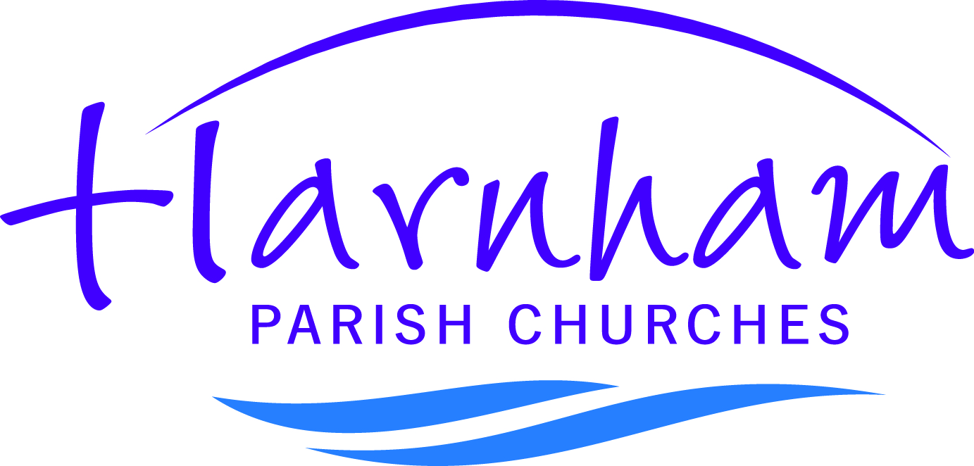

13th Sunday after Trinity
Sunday 10th September

WELCOME! A special welcome if you are visiting, or a newcomer.
You are invited to receive communion with us. If you would prefer a prayer of blessing, please bring a book with you.
If you would like to receive communion in your pew please let a sides-person know before we begin.

Should you wish to support the church financially there are gift aid envelopes, or alternatively you may prefer to give to the collection during the offertory hymn. The money goes towards the work of the Parish. 5% of this collection will support other Christian charities.

COLLECT:
Almighty God,
you search us and know us:
may we rely on you in strength
and rest on you in weakness,
now and in all our days;
through Jesus Christ our Lord. AMEN.

READINGS:
Romans 13.8-14 (P158)
Matthew 18: 15-20 (P18)

Would you please PRAY for:
- all affected by Hurricane Irma this week.
- the Diocese of Seychelles in the Indian Ocean (part of the Anglican Cycle of Prayer).
- all the parishes in the Bradford Deanery.
- the Orthodox Community, Alabare Christian Community and La Retraite Community.
- those attending and those helping at Messy Church this afternoon.
- all who live in Lower Street and Mallard Close.
- those who are sick, and all who care for them, especially John Rumens, Gary Turner, David Slater, Rachel Woods,
Tom, Revd. Becky Roberts, Carol Parker, Mark Baker and David Nickol.
- those who have died especially Peter Stapleforth,
Felicity Snelling, Beryl Gardner, Irene Light and
John Knogh.
-----------------------------------------------------------------------------------------------------------------------------------
HARVEST – Sunday 1st October 2017
There will be a Harvest “Bring and Share” lunch in the Church Hall this year. Lists will be in the churches shortly for you to sign up with your interest in attending, along with the food you would like to contribute to the event.

A Very Big Thank You!
Thank you to everyone who has been involved with the Pimms and Hymns afternoon at the start of August and last Sunday’s Pet Festival. Pimms and Hymns was enjoyed by around 50 people and raised £236.25 towards the new hall extension.
Over 60 people came along to the Pet Festival where
Revd. Penny Joyce led the Pet Service with the help of her puppet monkey. Then there was laughter and fun in the Scout Hut for the Dog Show and in the hall those who attended enjoyed some pet themed games, ice creams, the photo exhibition, stalls and refreshments. This event raised £113.80.

Another Thank You!
Thank you to everyone who helped Robert Salkeld and Anthony Bird yesterday looking after all the visitors to our churches as part of the Historic Ride and Stride.

PARISH DIARY

TODAY
3.00pm Messy Church in the Church Hall.

MONDAY – 11th September 2017
9.30am 3B’s in the Church Hall.
3.30pm Holy Communion at Harnham Croft.

TUESDAY – 12th September 2017
11.00am Holy Communion at Brympton.
1.00pm Bible Study in the Meeting Room.

WEDNESDAY – 13th September 2017
2.30pm Visit by Wilton MU to St.George’s for a talk by
William Alexander.

THURSDAY – 14th September 2017
10.00am Communion at St.George’s including MU
Corporate Communion.

FRIDAY – 15th September 2017
6.00pm Wedding Rehearsal at St.George’s.

SATURDAY – 16th September 2017
10.00am Coffee at All Saints.
2.00pm Thomas Blanchard and Sacha Hayward’s wedding
at St.George’s.

SUNDAY – 17th September 2017
8.00am Communion at All Saints.
9.30am Communion at St.George’s.
11.00am Communion at All Saints.
3.45pm Evensong at Willowcroft.

Please Note
Just for a couple of weeks the Parish Office will not be open on a Friday morning, this is just so that I can be around home whilst my husband recovers from major surgery. Otherwise it will be business as usual. Sorry for any inconvenience. Linda Baker.

