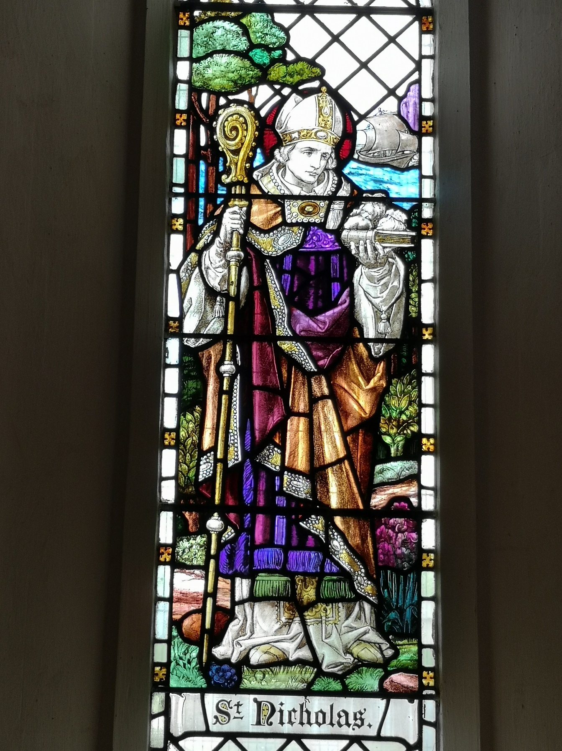

ADVENT and CHRISTMAS
2024
St George’s, All Saints and Messy Church in Harnham.

170 years of All Saints Church. Stained glass window of St Nicholas in All Saints. Note the bags of coins used to rescue small children from poverty and the Bible on which they rest as a symbol of this action being done as living out the Good News of Jesus Christ.
If you need support this winter.
Please ring the Parish Office 07925 108856
Revd Becky 01722 333564
Sundays in December
1st
10am Advent GIFT SUNDAY united communion
Service and Collection of vouchers (£5 or £10) for the Women’s Refuge. All Saints’ Church.
8th
8am All Saints said morning communion.
10am United sung Advent service St George’s Church.
3pm, Christingle Family Service. St George’s Church. Followed by tea hosted by Messy Church in the Parish Hall. Collection for the Children’s Society.
15th
10am United sung Advent service All Saints’ Church.
22nd
8am said morning communion. All Saints’ Church.
10am United sung Advent Communion service. St George’s Church. Revd Mike Badger’s last service in Harnham.
6.30pm Carol service.
29th
10am. First Sunday of Christmas. Poetry, and said communion. St Geroge’s.

Extra Advent and Christmas services and events.
Tuesday Advent Talks ‘Do Not Be Afraid’ 8pm
St George’s. 2nd 9th 16th December. Talks followed by Compline night prayer.
THURSDAY 12th December, Beer and Carols 7- 9pm
Community Carol singing. Come and sing, donate to our charities and buy a drink or two! The Old Mill Pub and Hotel. Harnham.
Sunday 22nd December, Carol Service 6.30pm
Christmas Carol Service with guest choir. All Saints’ Church.
Tuesday 24th December, Christmas Eve
4pm. Blue Christmas. Service of light for those who find Christmas difficult with a chance to hang lights in remembrance of a loved one or situation. St George’s Church.
4pm All Age Nativity service. All Saints Church.
11.30pm Midnight Mass. St George’s Church.

Wednesday 25th December, Christmas Day
9.30am St George’s - Christmas Communion with carols and children’s talk.
11am All Saints - Christmas Communion with carols and children’s talk.

